**DAILY ONLINE ACTIVITIES SUMMARY**

|  |  |  |  |  |  |  |  |  |
| --- | --- | --- | --- | --- | --- | --- | --- | --- |
| **Date:** | **18-06-2020** | | | | | **Name:** | **Dhanush Shetty** | |
| **Sem & Sec** | **8 A** | | | | | **USN:** | **4AL16CS032** | |
| **Online Test Summary** | | | | | | | | |
| **Subject** | | **SMS** | | | | | | |
| **Max. Marks** | | **60** | | **Score** | | | **Not received mail** | |
| **Certification Course Summary** | | | | | | | | |
| **Course** | **AWS Elemental Foundations.** | | | | | | | |
| **Certificate Provider** | | | **AWS** | | **Duration** | | | **10 mins** |
| **Coding Challenges** | | | | | | | | |
| **Problem Statement:**   1. **Write a C Program to generate first N Magic Numbers**. | | | | | | | | |
| **Status: Solved** | | | | | | | | |
| **Uploaded the report in Github** | | | | | **Yes** | | | |
| **If yes Repository name** | | | | | **Dhanushshett/online_c_coding_repository** | | | |
| **Uploaded the report in slack** | | | | | **Yes** | | | |

Online Test Details:

Did not receive mail regarding scores.

Certification Course Details:

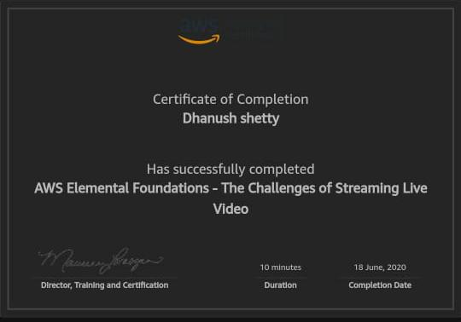

Coding Challenges Details:

**PROGRAM 1 .**

**//Write a C Program to generate first N Magic Numbers**

**#include <stdio.h>**

**int nthMagicNo(int n)**

**{**

**int pow = 1, answer = 0;**

**while (n)**

**{**

**pow = pow*5;**

**if (n & 1)**

**answer += pow;**

**n >>= 1; // or n = n/2**

**}**

**return answer;**

**}**

**int main()**

**{**

**int n = 5;**

**printf("nth magic number is %d\n",nthMagicNo(n));**

**return 0;**

**}**